Face in Solid Geometry
# Source: AI Source: Provided by: [Data Path: Persons Table -> ID Column: 1, Name_En Column: Motasem Essam] -> From: [ChatGPT] on [7/25/2026]
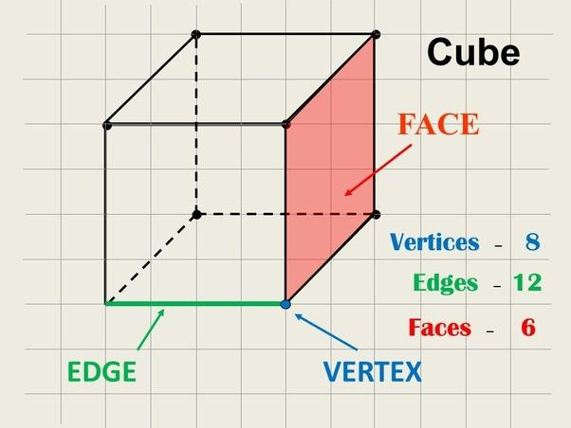
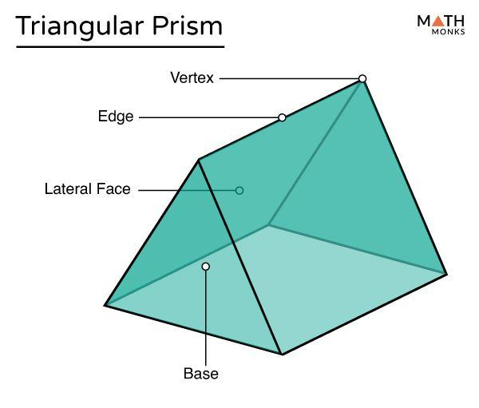
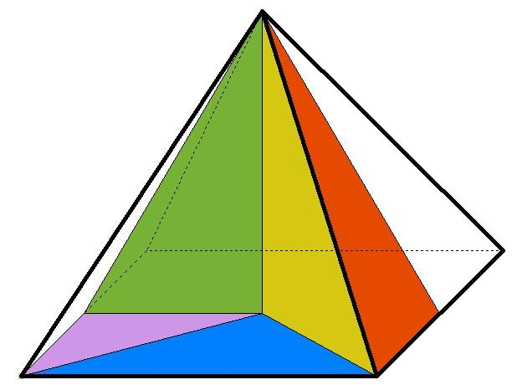

Definition
# Source: AI Source: Provided by: [Data Path: Persons Table -> ID Column: 1, Name_En Column: Motasem Essam] -> From: [ChatGPT] on [7/25/2026]
A face in Solid Geometry is a surface that forms part of the boundary of a three-dimensional solid. In a polyhedron, a face is a flat polygon bounded by straight edges.
Faces meet along edges, and edges meet at vertices. Together, these elements define the structure of a polyhedron.

Simple Definition
# Source: AI Source: Provided by: [Data Path: Persons Table -> ID Column: 1, Name_En Column: Motasem Essam] -> From: [ChatGPT] on [7/25/2026]
A face is a surface of a solid.
For example, a cube has 6 square faces, and each face is a flat square.

Key Characteristics
# Source: AI Source: Provided by: [Data Path: Persons Table -> ID Column: 1, Name_En Column: Motasem Essam] -> From: [ChatGPT] on [7/25/2026]
- Two-dimensional: A face has length and width but no thickness as a geometric surface.
- Boundary element: Faces form part of the outer boundary of a solid.
- Shape: A polyhedral face is a polygon, such as a triangle, square, or pentagon.
- Bounded by edges: The edges form the perimeter of a polygonal face.
- Measurable area: The area of a face can be calculated using appropriate geometric formulas.
- Shared boundaries: Adjacent faces of a polyhedron meet along a common edge.

Types of Faces in Solid Geometry

1. Polygonal Face
# Source: AI Source: Provided by: [Data Path: Persons Table -> ID Column: 1, Name_En Column: Motasem Essam] -> From: [ChatGPT] on [7/25/2026]
A flat surface bounded by straight edges and forming a polygon.
Examples: Triangular faces of a tetrahedron and square faces of a cube.
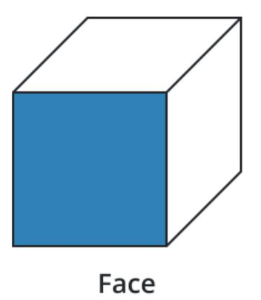

2. Base Face
# Source: AI Source: Provided by: [Data Path: Persons Table -> ID Column: 1, Name_En Column: Motasem Essam] -> From: [ChatGPT] on [7/25/2026]
A face that serves as a base of a solid, especially a prism or pyramid.
Examples: The two pentagonal bases of a pentagonal prism; the square base of a square pyramid.
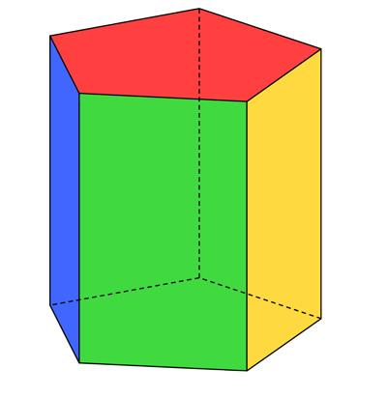

3. Lateral Face
# Source: AI Source: Provided by: [Data Path: Persons Table -> ID Column: 1, Name_En Column: Motasem Essam] -> From: [ChatGPT] on [7/25/2026]
A face connecting or surrounding the bases of a solid, excluding the bases themselves.
Examples: The three rectangular lateral faces of a right triangular prism.

4. Regular and Irregular Faces
# Source: AI Source: Provided by: [Data Path: Persons Table -> ID Column: 1, Name_En Column: Motasem Essam] -> From: [ChatGPT] on [7/25/2026]
A regular polygon has equal sides and equal interior angles. An irregular polygon does not satisfy both conditions.
Examples: A square is a regular face; a non-square rectangle is an irregular polygonal face.
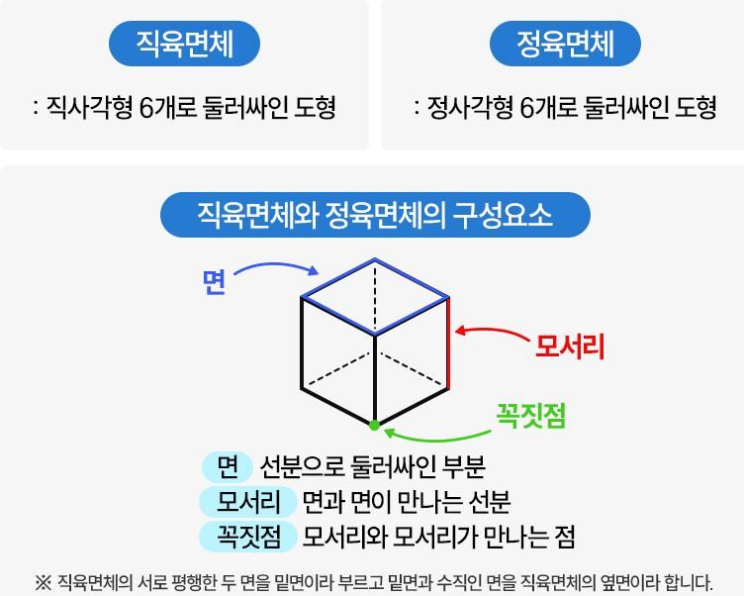

Number of Faces in Common Solids
# Source: AI Source: Provided by: [Data Path: Persons Table -> ID Column: 1, Name_En Column: Motasem Essam] -> From: [ChatGPT] on [7/25/2026]
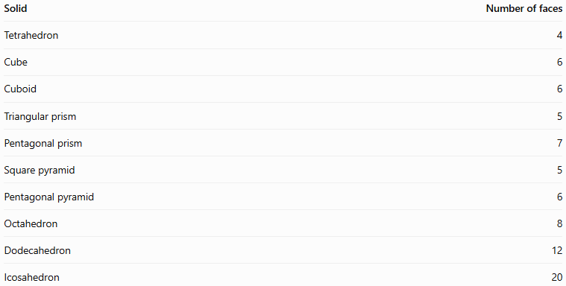
Solid | Number of faces
Tetrahedron | 4
Cube | 6
Cuboid | 6
Triangular prism | 5
Pentagonal prism | 7
Square pyramid | 5
Pentagonal pyramid | 6
Octahedron | 8
Dodecahedron | 12
Icosahedron | 20
Important distinction: These counts refer to flat polygonal faces. A sphere has one continuous curved surface, while a cylinder has one curved surface and two flat circular bases. In strict polyhedral terminology, curved surfaces are not polygonal faces.

Fundamental Properties

1. Face Shape and Area
# Source: AI Source: Provided by: [Data Path: Persons Table -> ID Column: 1, Name_En Column: Motasem Essam] -> From: [ChatGPT] on [7/25/2026]
Each polygonal face has a shape and an area. The formula depends on the polygon.
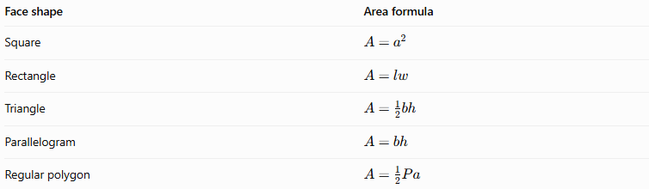
Face shape | Area formula
Square | $$A=a^{2}$$
Rectangle | $$A=lw$$
Triangle | $$A=\frac{1}{2}bh$$
Parallelogram | $$A=bh$$
Regular polygon | $$A=\frac{1}{2}Pa$$
Here, $a$ is the square's side length; $l$ and $w$ are rectangle dimensions; $b$ and $h$ denote base and perpendicular height; $P$ is the perimeter of a regular polygon; and $a$ in the final formula denotes its apothem.

2. Faces and Edges
# Source: AI Source: Provided by: [Data Path: Persons Table -> ID Column: 1, Name_En Column: Motasem Essam] -> From: [ChatGPT] on [7/25/2026]
The edges of a polygon form the boundary of its face.
For a convex polyhedron, every edge belongs to exactly two faces. For example, each of the 12 edges of a cube is shared by two square faces.

3. Faces and Vertices
# Source: AI Source: Provided by: [Data Path: Persons Table -> ID Column: 1, Name_En Column: Motasem Essam] -> From: [ChatGPT] on [7/25/2026]
The corners of a polygonal face are vertices of the polyhedron.
A square face has 4 vertices. However, when counting the vertices of an entire solid, shared vertices must not be counted repeatedly.

4. Total Surface Area
# Source: AI Source: Provided by: [Data Path: Persons Table -> ID Column: 1, Name_En Column: Motasem Essam] -> From: [ChatGPT] on [7/25/2026]
The total surface area of a polyhedron is the sum of the areas of all its faces.
$$\boxed{S=\sum_{i=1}^{F}{A_{i}}}$$
where $A_{i}$ is the area of the $i$-th face and $F$ is the total number of faces.
For a cube with side length $a$,
$$\boxed{S=6a^{2}}$$
because the cube has six congruent square faces, each with area $a^{2}$.

5. Euler's Formula
# Source: AI Source: Provided by: [Data Path: Persons Table -> ID Column: 1, Name_En Column: Motasem Essam] -> From: [ChatGPT] on [7/25/2026]
For a convex polyhedron,
$$\boxed{V-E+F=2}$$
where $V$ is the number of vertices, $E$ is the number of edges, and $F$ is the number of faces.
For a cube,
$$8-12+6=2$$
This formula relates the numbers of faces, edges, and vertices.

Faces of Common Solids

Cube
# Source: AI Source: Provided by: [Data Path: Persons Table -> ID Column: 1, Name_En Column: Motasem Essam] -> From: [ChatGPT] on [7/25/2026]
- 6 square faces
- All faces are congruent.
- Total surface area: $6a^{2}$.
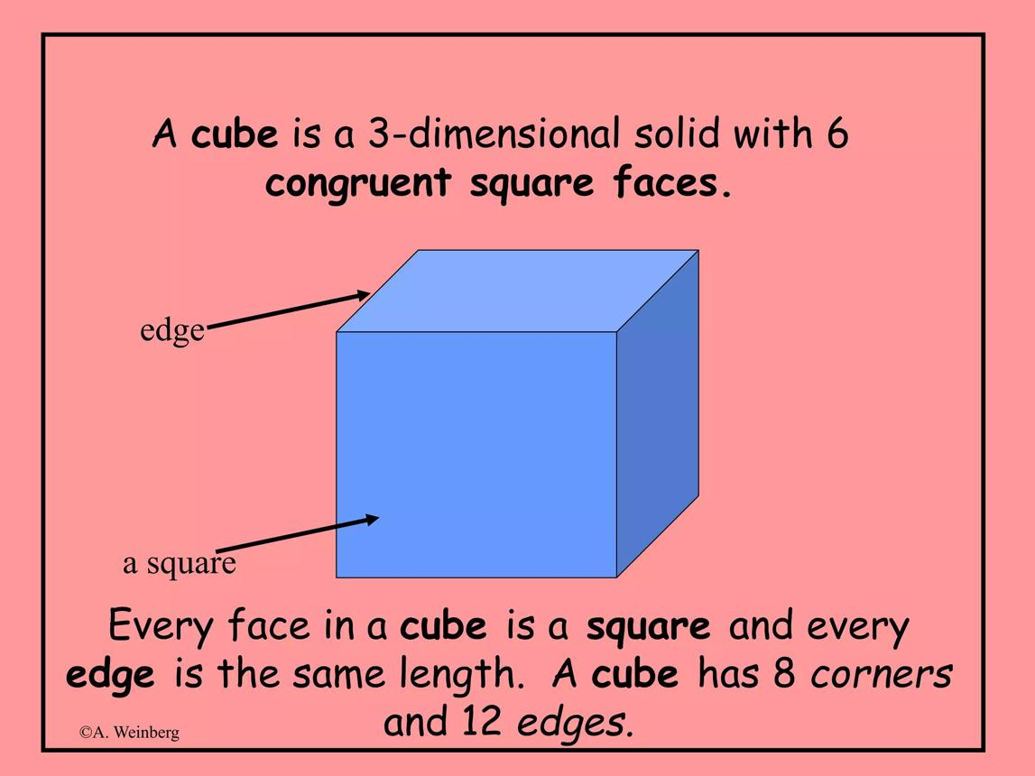

Cuboid
# Source: AI Source: Provided by: [Data Path: Persons Table -> ID Column: 1, Name_En Column: Motasem Essam] -> From: [ChatGPT] on [7/25/2026]
- 6 rectangular faces
- Opposite faces are congruent.
- Total surface area: $2\left(lw+lh+wh\right)$.
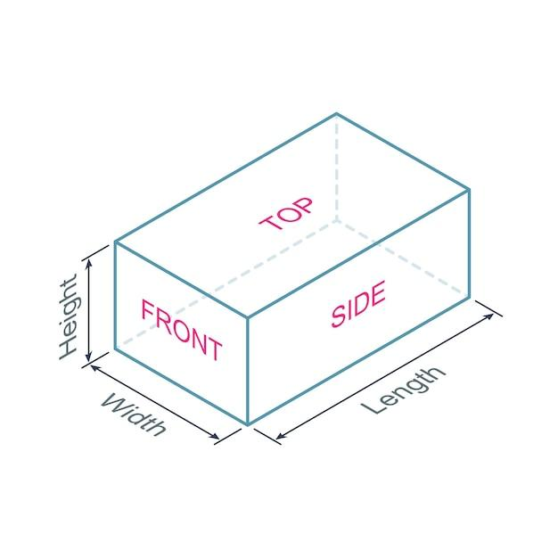

Square Pyramid
# Source: AI Source: Provided by: [Data Path: Persons Table -> ID Column: 1, Name_En Column: Motasem Essam] -> From: [ChatGPT] on [7/25/2026]
- 5 faces: 1 square base and 4 triangular lateral faces.
- Total surface area equals the base area plus the areas of all four triangles.
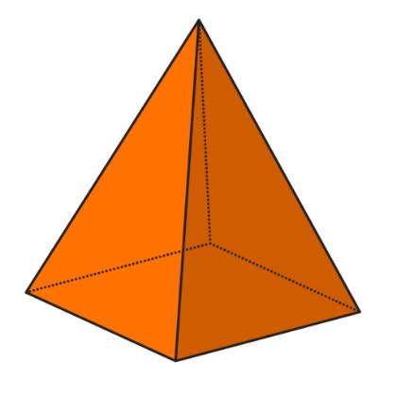

Triangular Prism
# Source: AI Source: Provided by: [Data Path: Persons Table -> ID Column: 1, Name_En Column: Motasem Essam] -> From: [ChatGPT] on [7/25/2026]
- 5 faces: 2 triangular bases and 3 rectangular lateral faces in a right prism.
- The two triangular bases are congruent.
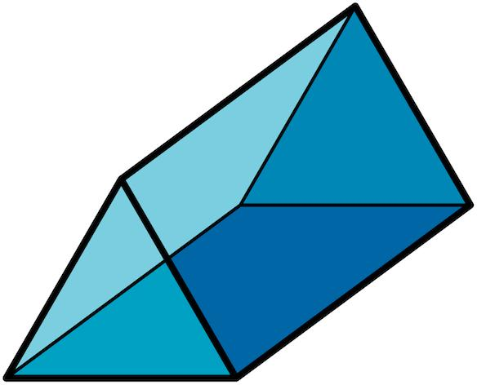

Face vs. Edge vs. Vertex vs. Surface
# Source: AI Source: Provided by: [Data Path: Persons Table -> ID Column: 1, Name_En Column: Motasem Essam] -> From: [ChatGPT] on [7/25/2026]
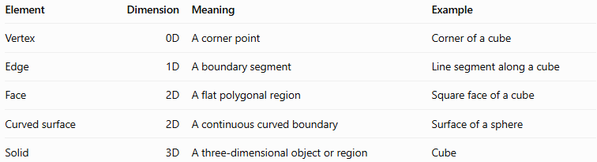
Element | Dimension | Meaning | Example
Vertex | 0D | A corner point | Corner of a cube
Edge | 1D | A boundary segment | Line segment along a cube
Face | 2D | A flat polygonal region | Square face of a cube
Curved surface | 2D | A continuous curved boundary | Surface of a sphere
Solid | 3D | A three-dimensional object or region | Cube

Applications
# Source: AI Source: Provided by: [Data Path: Persons Table -> ID Column: 1, Name_En Column: Motasem Essam] -> From: [ChatGPT] on [7/25/2026]
- Geometry: Classifying polyhedra by the number and shapes of their faces.
- Architecture: Describing walls, panels, and planar surfaces.
- Engineering: Calculating surface areas and designing components.
- Computer graphics: Representing 3D models using polygonal meshes.
- Manufacturing: Planning flat panels and sheet materials.
- Mathematics: Applying Euler's formula and solving surface-area problems.

Key Points
# Source: AI Source: Provided by: [Data Path: Persons Table -> ID Column: 1, Name_En Column: Motasem Essam] -> From: [ChatGPT] on [7/25/2026]
- A face is a two-dimensional boundary element of a solid.
- In a polyhedron, each face is a flat polygon.
- Base faces form the bases of prisms and pyramids.
- Lateral faces connect or surround the bases.
- A cube has 6 square faces; a triangular prism has 5 faces.
- Total surface area is the sum of the areas of all boundary faces or surfaces.
- Curved surfaces should be distinguished from flat polygonal faces.

Conclusion
# Source: AI Source: Provided by: [Data Path: Persons Table -> ID Column: 1, Name_En Column: Motasem Essam] -> From: [ChatGPT] on [7/25/2026]
A face in Solid Geometry is a two-dimensional boundary element that helps define the shape of a three-dimensional solid. In polyhedra, faces are flat polygons connected by edges and meeting at vertices. Understanding faces is essential for classifying solids, calculating surface area, studying geometric relationships, and constructing three-dimensional models.
Recommended classification:
Mathematics → Geometry → Euclidean Geometry → Solid Geometry → Face

